Viewing and Responses

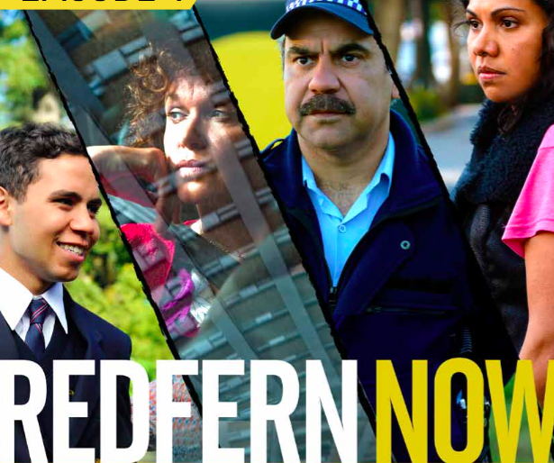

Student:

Introduction

Redfern Now (Series 1) explores contemporary inner city Indigenous life. Over six extraordinary episodes, the series portrays life in the suburb of Redfern in Sydney, New South Wales. They offer compelling and challenging stories of ordinary people whose lives are changed by a quirk of fate.

Redfern Now is the first drama series written, directed and produced by Indigenous Australians and has a mostly indigenous cast.
(produced by Blackfella films – see online at http://blackfellafilms.com.au/)
The series offers stories of Indigenous Australians told by Indigenous Australians, allowing students to develop an awareness and appreciation of Indigenous storytelling and to see the issues affecting an Indigenous Australian community from an Indigenous perspective.
Each episode 55 minutes

Before Viewing
- Make a list of other texts that you have watched, read or listened to that tell the stories of Indigenous Australians.
  - Did Indigenous Australians create these texts?
  - Why is it important to experience texts told from an Indigenous Australian perspective?

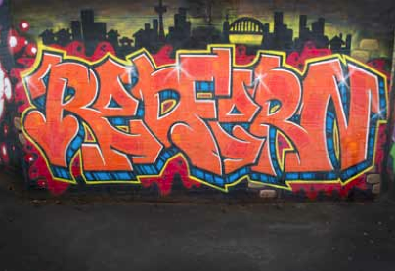
- What do you know about the inner Sydney suburb of Redfern? Have you ever been to Redfern? What sort of reputation does Redfern have?
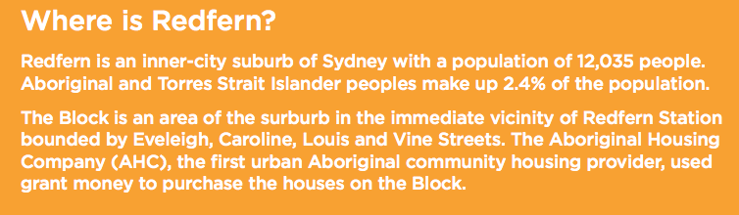

- Watch the opening title sequence of Redfern Now. Make a list of everything you see and hear. How does this sequence portray Redfern and the people who live there?

Background Research

- Who are Blackfella films? Why and how did they develop Redfern Now into a television drama series?

- Find Redfern on googlestreetview and have a look around. Write 1 – 2 sentences on your impressions. Or just write your impressions if you have been to Redfern.

- Read the words of the Australian national anthem. Write 2 – 3 dot points under each heading giving your ideas about it:
- What does it mean to you?

- What are some of the key words or lines?

- What is it for?

- Shari Sebbens and Miranda Tapsell have roles in the Australian feature film The Sapphires (Wayne Blair, 2012) . Sebbens plays Kay and Tapsell plays Cynthia, two members of a quartet of young, talented singers from a remote Aboriginal mission. If you have seen The Sapphires give your opinion of the film and comment on the roles played by Sebbens and Tapsell. Otherwise watch a preview and comment.

- Write a definition of ‘reconciliation’.

- Explain what ‘identity’ is. Write approximately 100 words about ‘identity’ - either your personal identity or about the identity of a group where you feel you belong.

Viewing Responses “Stand Up”
- Write key words for each of the characters on their actions, appearance and speech:
WillWCCC CHARACTER | KEY WORDS
Eddie Shields is pushing forty years of age. Married, with a teenage son and a mortgage, Eddie is proud of his Indigenous roots and unafraid to stand up for himself and his beliefs, He wants his teenage son to have more opportunities than he did.
Nic Shields set her sights on Eddie from the sidelines at the local under-20 rugby and they have been together ever since. Their son Joel is the centre of her universe, and she has high hopes for him.
Joel Shields at sixteen years of age is a typical teenager. Joel is close to both his parents but idolises his father. He is happy to have gained a place at Clifton Grammar and is keen to do well at his new school.
Mrs McCann is the principal of Clifton Grammar. A traditionalist, she believes that rules are rules. Her understanding of reconciliation is challenged by Joel’s refusal to sing ‘Advance Australia Fair’.
Mr Parish is Joel’s English teacher. Mrs McCann expects that Mr Parish will convince Joel to sing ‘Advance Australia Fair’. His unquestioning support of the rules at Clifton Grammar is challenged by Joel’s convictions.
Chloe is a student at Clifton Grammar. Like Joel, she is a scholarship student. Joel is smitten with Chloe from the moment he first sees her.
Mr Moore is the Aboriginal Liaison at Clifton Grammar. He is incapable of challenging McCann’s authority, and as a consequence does not provide Joel or his parents with the support they need.

- List the main events in the plot or summarise the story.
- Joel’s actions tell a great deal about him. Select two incidents from the film where Joel’s actions give us an insight into his character.

Example 1:

Example 2:

- How does Joel change? What does he discover and learn?

- What is Joel’s future? Write your opinion on what his life and circumstances will be one year later. Where will he be and what will he be doing? Will he be happy?

Viewing Responses “Joyride”

- Write key words for each of the characters about their values and attitudes:
WillWCCC CHARACTER | KEY WORDS
CORAL
JULIE
DANNY
TENEKA
GAZ
AARON DAVIS
- Statement: Danny does not deserve to be forgiven.

Agree or Disagree? __________________________________________________________________
Explain:

- Why do Coral’s budgies keep dying?

- List the settings in the story.

- Choose one of the characters. What is their future? Write your opinion on what their life and circumstances will be one year later. Where will they be and what will they be doing? Will they be happy? Give some evidence for your ideas.

